

**PROJECT PLAN AND FOURTH INCREMENT REPORT**

**SPRING 2017**



**Team – 1  
 Nageswara, Rao Nandigam – 61  
 Chakilam, Revanth – 9**

**Syed, Moin – 86**

**Sarda, Devender – 82**

**Table of Contents**

1. Project Goals and Objectives……………………………………………………….3
2. Project Plan and Management…………………………………………………… 4
3. Project timeline and responsibility………………………………………………6
4. Functionality Report……………………………………………………………………8
   1. Wire Frames……………………………………………………………………….9
   2. Architecture Diagram………………………………………………………..15
   3. Class Diagram……………………………………………………………………15
   4. Sequence Diagram…………………………………………………………….16
   5. Use case Diagram……………………………………………………………..17
   6. Unit Test Cases………………………………………………………………….18
   7. Deployment………………………………………………………………………19
   8. API implementation………………………………………………………….22
   9. Project Management………………………………………………………..25
   10. Application Screenshot…………………………………………………….26
5. Bibliography………………………………………………………………………………51
6. **Project Goals and Objectives**

**Motivation:** In today’s busy-busy world, it’s hard to stay fit and keep track of what we should eat and what we shouldn’t. With this underlying motivation, we came up with an idea to create an application which helps you do just that. Stay fit by keeping track of your eating habits and exercise routines.

**Significance:** Though we have multiple applications on fitness and nutrition in the market place, this application stands out as it combines both the dietary plan and exercise routine which a user can follow to make a healthy living and also we have put image recognition functionality which is not available in many of the applications today.

**The Objective:** The objective of this application is to make people fit and make them follow a diet for a healthy lifestyle.

**System Features:**

1. Register & Sign Up Option.
2. Create a plan for individual user.
   1. We will take weight and height of the user while doing registration and set target for day, week and month.
3. Track user calories based on Food + Exercise = Total Calories.
4. Display user progress with intuitive graphs and charts.
5. Image Recognition: User can upload images of food item’s he/she consumes, and our application calculates the approximate calories based on the image and food.
6. Exercise
   1. User has an option to select different exercises and enter inputs to track calories burned.
7. Pie chart
   1. You will have pie chart that for calories from meals. i.e. Breakfast, lunch and dinner.
8. **Project Plan and Management**
9. **Project Plan:** Schedule for the whole project is created

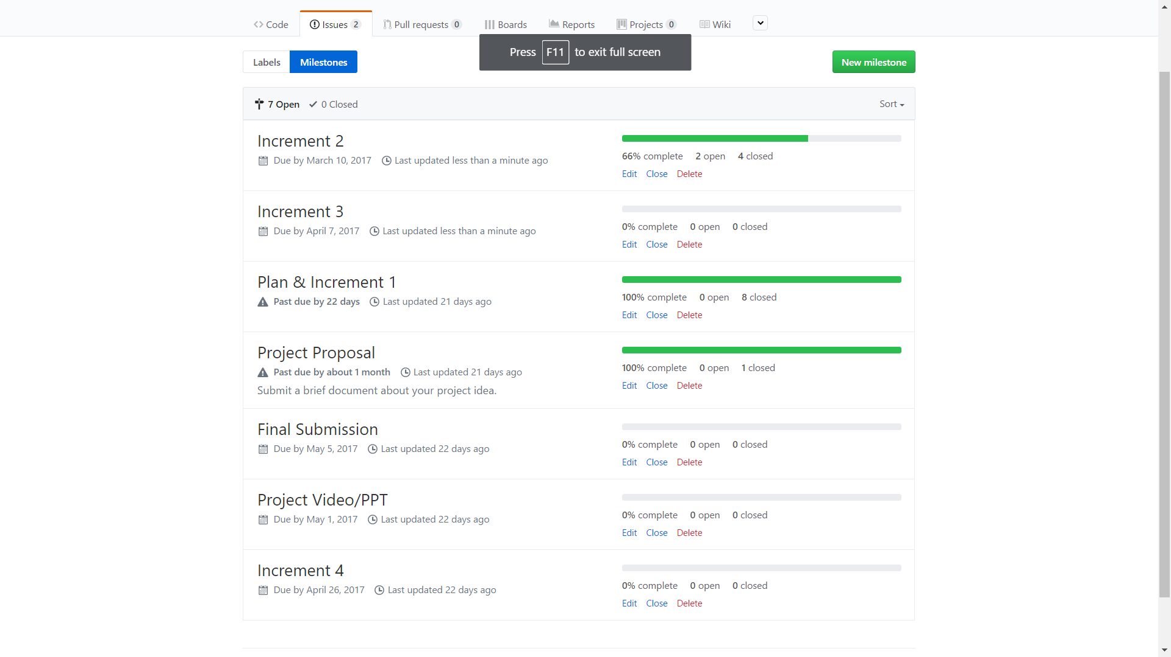

1. **Tasks and Issues Screenshot:**

These are the issues that describe the tasks with contributors allocated on each and every tasks. It is assigned with the level of difficulty and the tasks are successfully closed as they are completed.

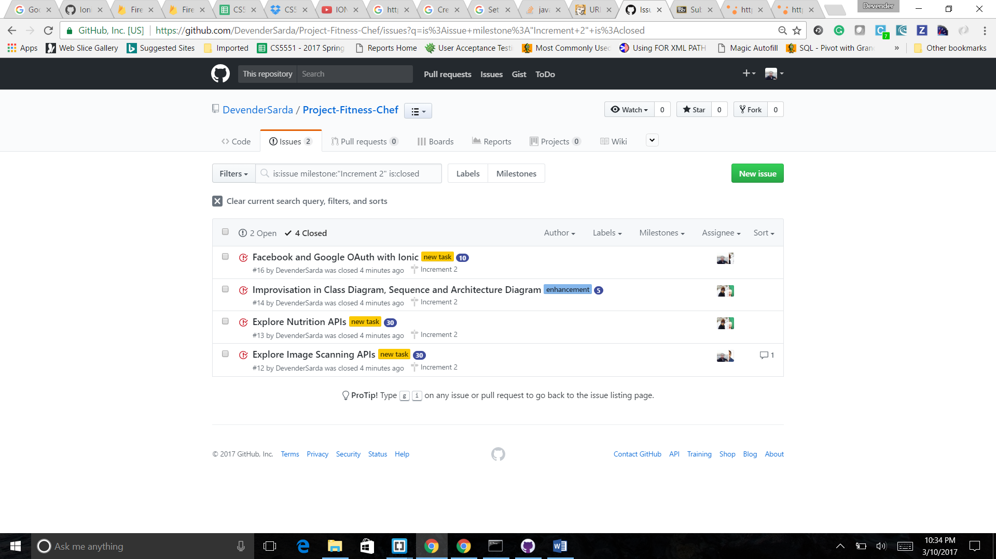

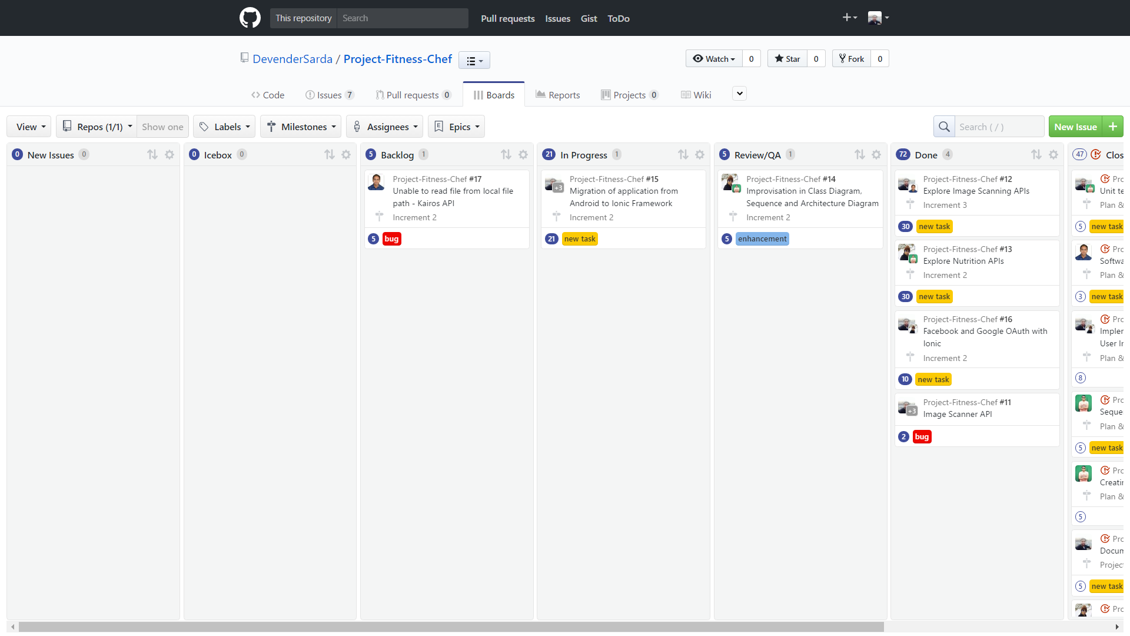

1. **Project Timelines and Task Responsibility**

**3.2.1 Project Timelines**

The Project is submitted in 4 increments and the aim is to achieve the said goals and tasks reported in the project

**3.2.2 Members**

• Nageswara Rao Nandigam

• Syed Moin

• Revanth Chakilam

• Devender Sarda

**3.2.3 Task Responsibility**

Each member has their own task and projected with limited timeline. Nageswara Rao Nandigam implemented Kairos API and nutrition API , helped in documentation & unit testing of the application. Devender implemented Fitness News Feed/Tips API like Get News API, involved in project management, documentation and unit testing. Syed Moin implemented Register pages, profile page of the user, involved in documentation and unit testing. Revanth Chakilam implemented Fitness part of the application i.e., he implemented Exercises gifs and calculation of calories based on exercise done and majorly involved in styling and designing of the application.

1. **Burn Down Chart**

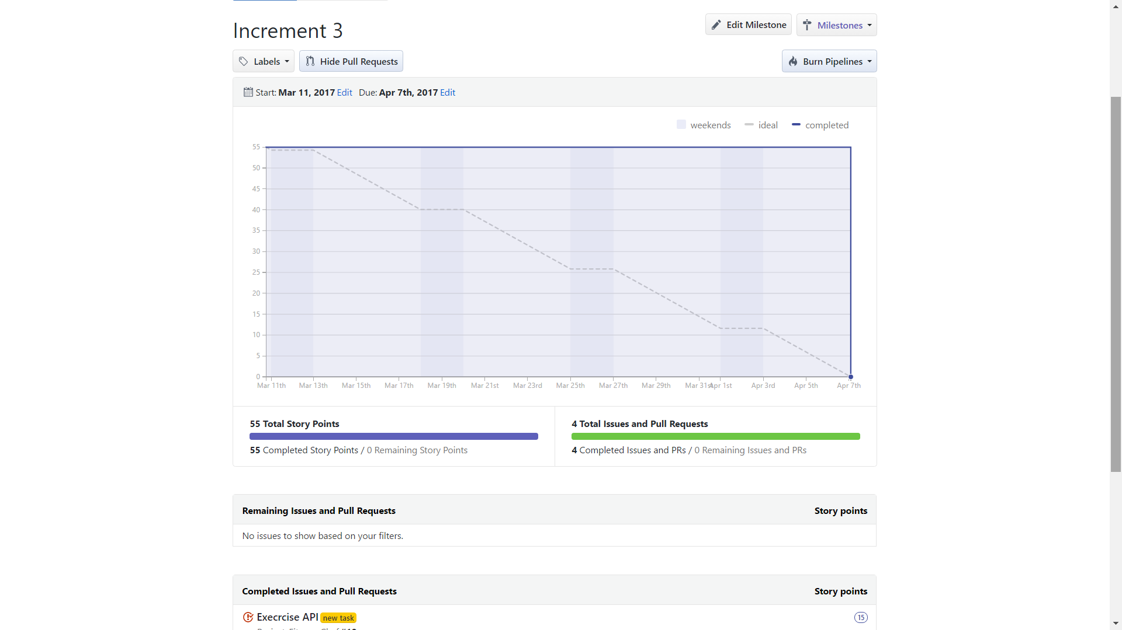

**4. Functionality Report**

The Project fitness chef mostly focusses on the nutrition and health benefits.

In the project, we have mainly concentrated on integrating our application and connection all the apis explored. We have completed the major chunks of our application with a little bit of styling and features to be added for the last increment.

The user having an account can login directly. New Users has the facility to sign up in to the application. The new users can create an account based on the personal email id or through the social network Authentication. End users are provided with a choice to select the Authentication using either Facebook or Google. Once the user connects to the application. He/she should set a goal whether to gain the weight or lose the weight or maintain the stability.

The users are asked with their height and weight in order to calculate the amount of calories intake and suggest them optimum nutrition for the betterment of their health.

In the details section, the users are asked to provide the personal details including location and date of birth.

From the user entered details an API is called based on the inputs and the necessary result is collected from the API in JSON format .

* 1. **Existing Services/ REST API:**
* Facebook OAuth API using Ionic
* Google OAuth API using Ionic
* Android studio framework
* Storage using Shared Preferences
  1. **Detail Design of Features:**
     1. **Wireframes and Mockups**

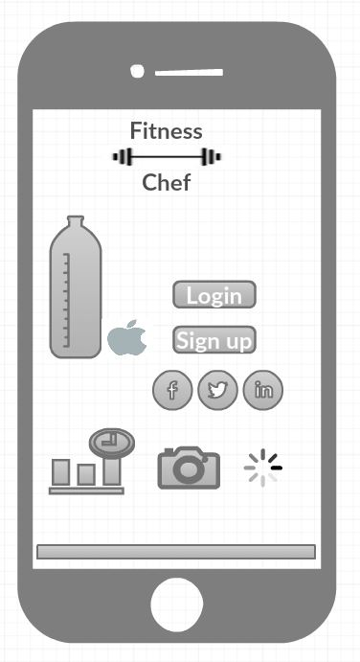

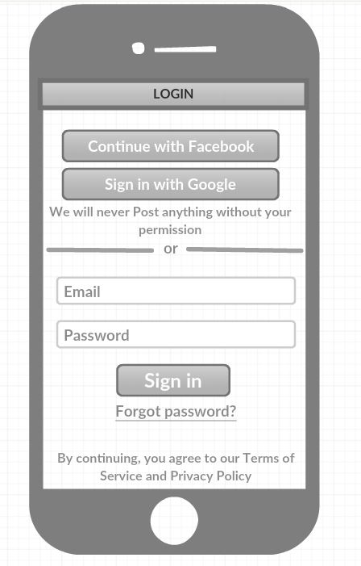

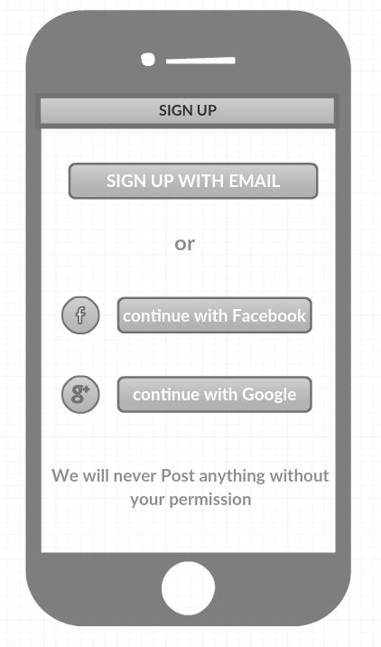

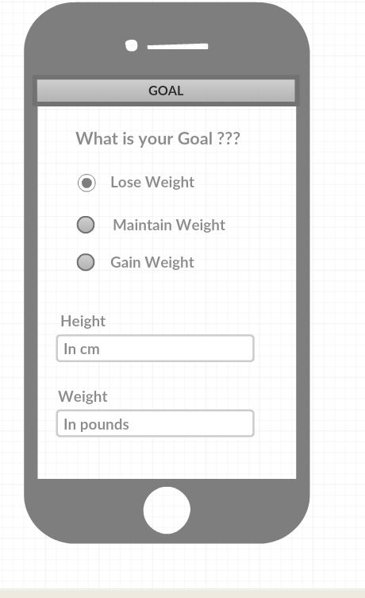

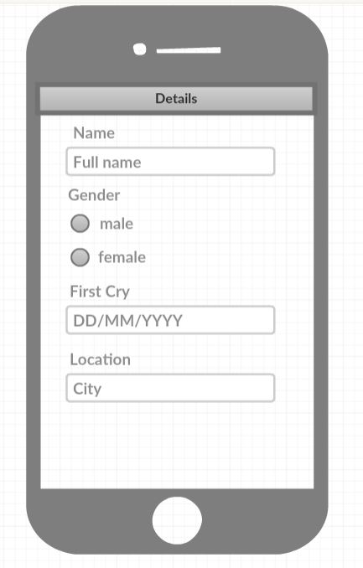

* + 1. **Architecture diagram/Sequence diagram/Class diagram/Use case diagram**

**Class diagram**

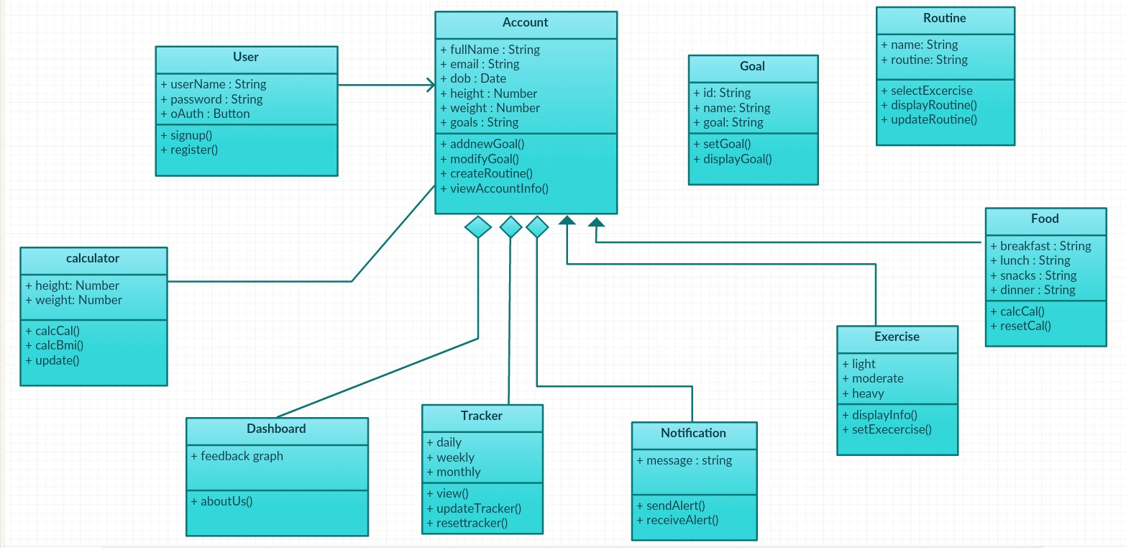

**Architecture diagram**

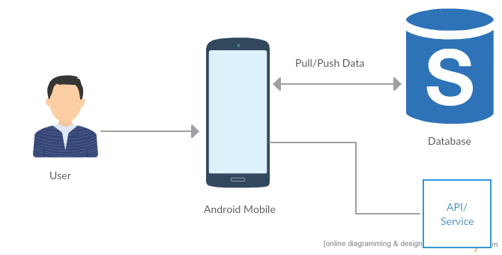

**Sequence Diagram**

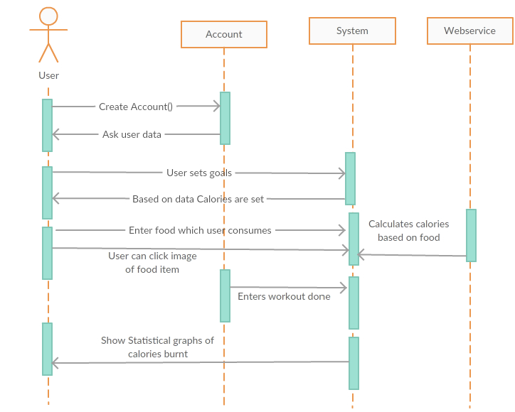

**Use case Diagram**

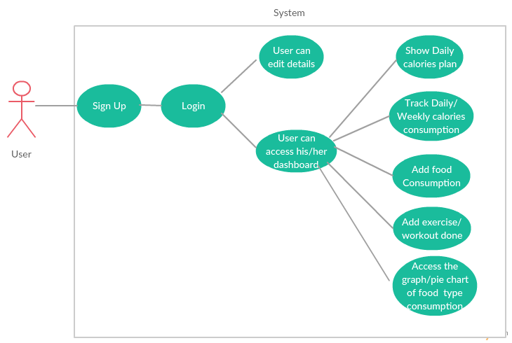

* 1. **Testing:**

**Unit test cases**

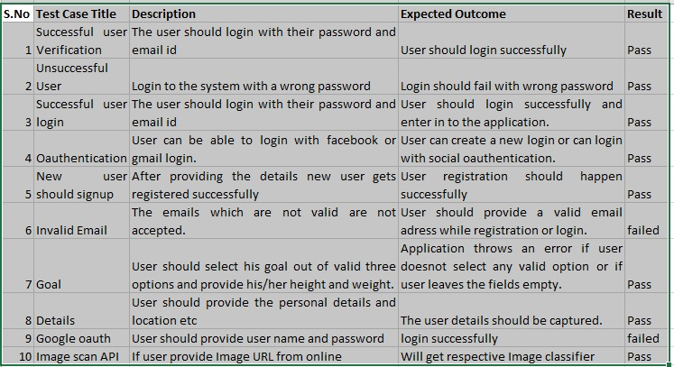

* 1. **Deployment**

**Main Page**

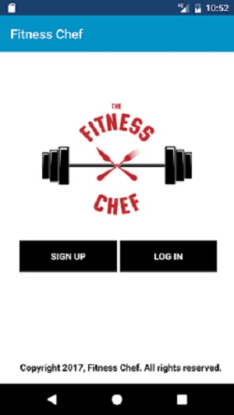

**Login Page**

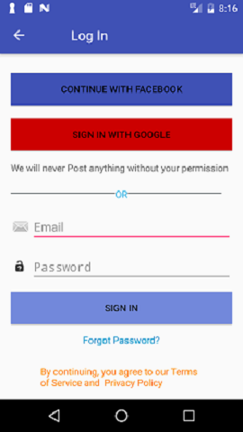

**Login Page validations**

* + - * **When user leaves the login fields empty**

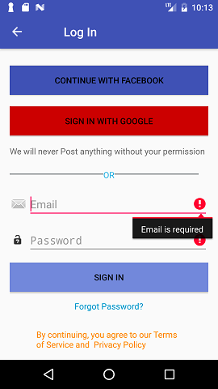

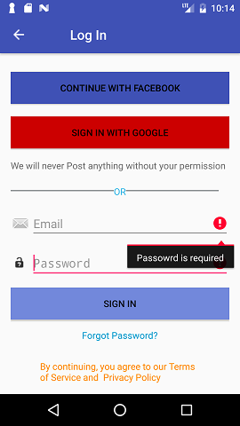

* + - * **When the email and password mismatches**

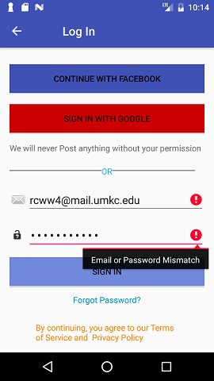

**Signup page**

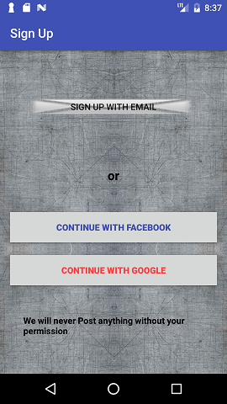

**Oauth Facebook**

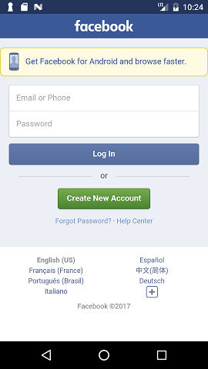 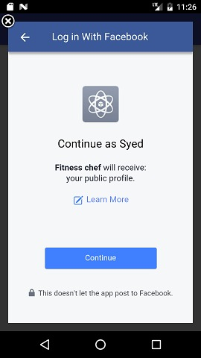

**Goal Page**

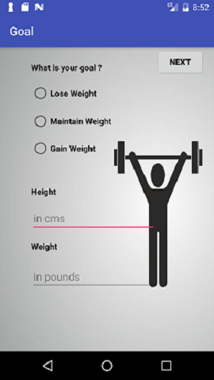

**Goal Page Validations:**

* + - * **When user leaves the fields empty**

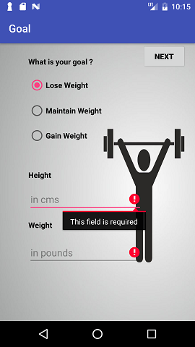

**Details page**

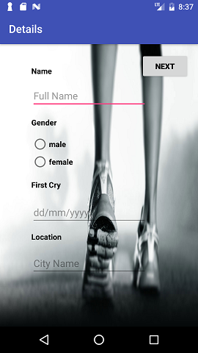

**4.4.2 APIs used in the Application**

We explored multiple image scanning APIs and narrowed down to 2 APIs: Google Cloud API and IBM Kairos visual recognition.

Image Scanning API using Google Cloud API:

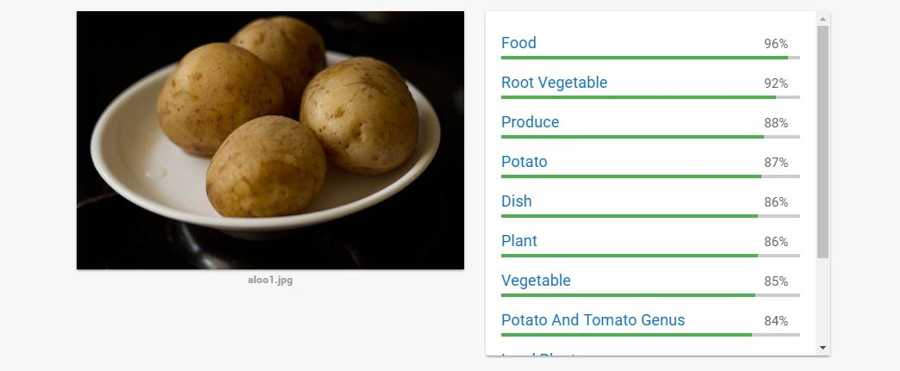

IBM Kairos API:

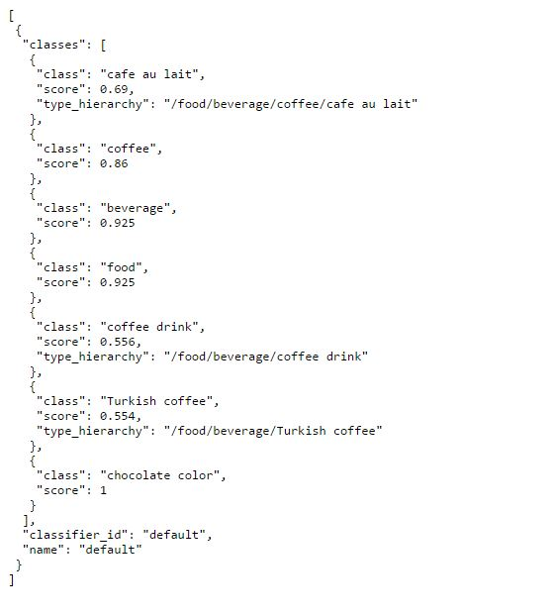

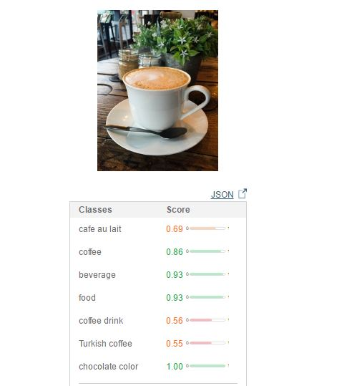

Nurtition APIs – NurtitionIX

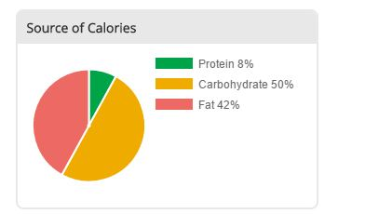

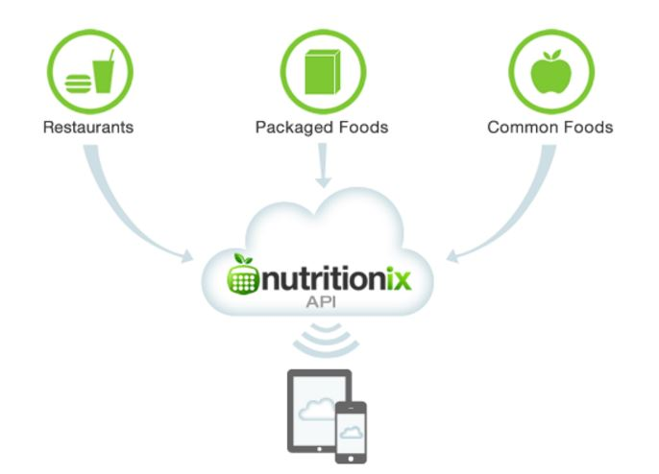

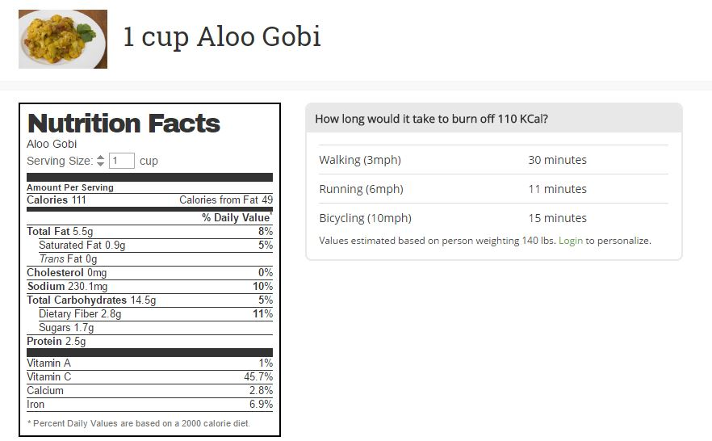

**4.4.3 Application Screenshots:**

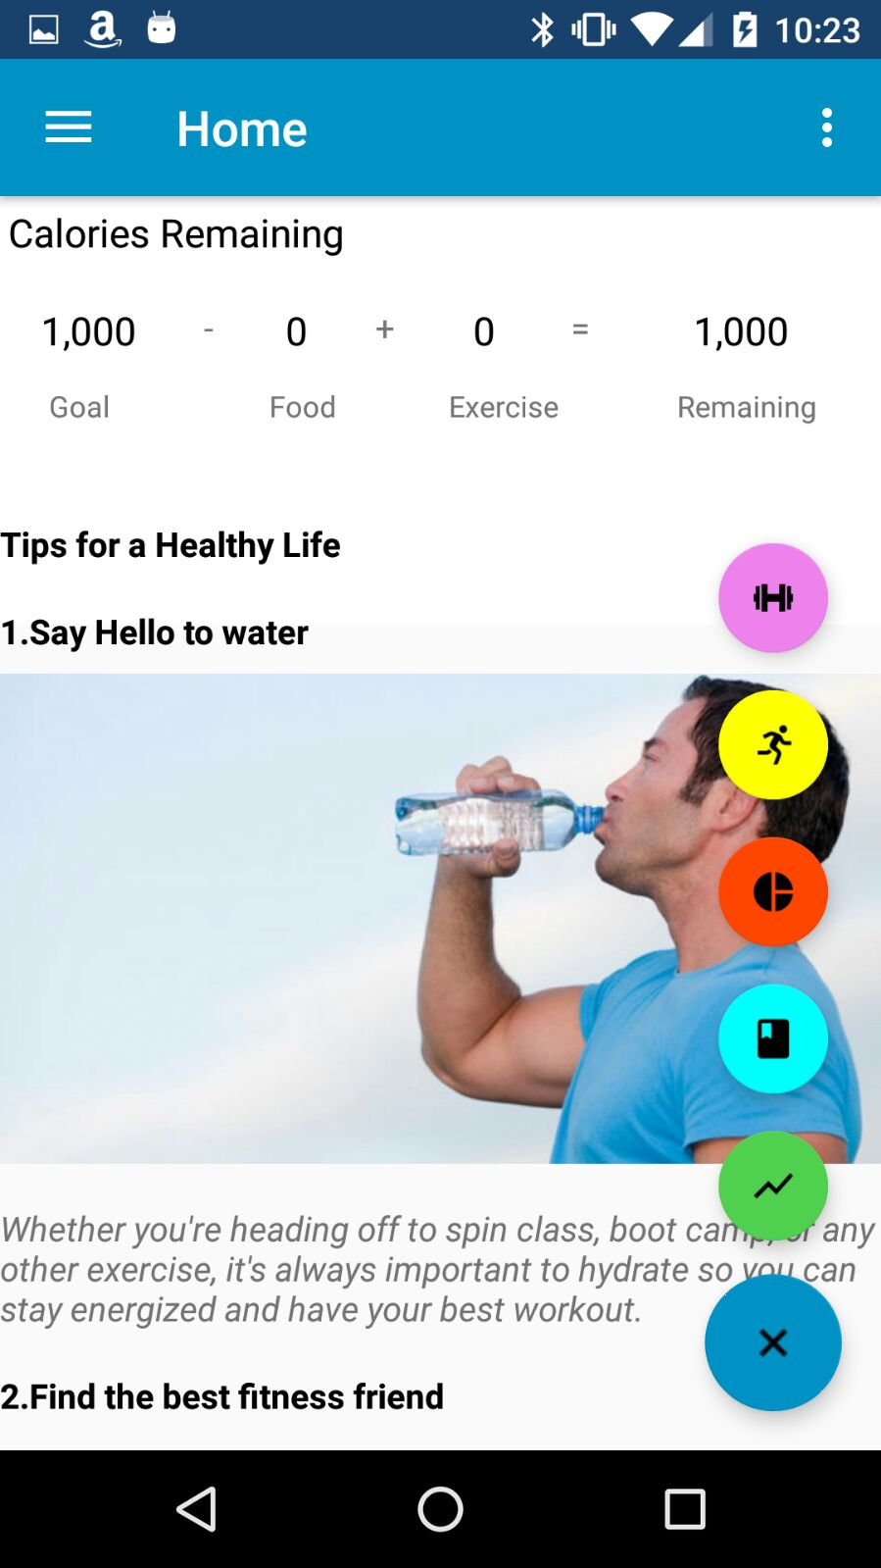

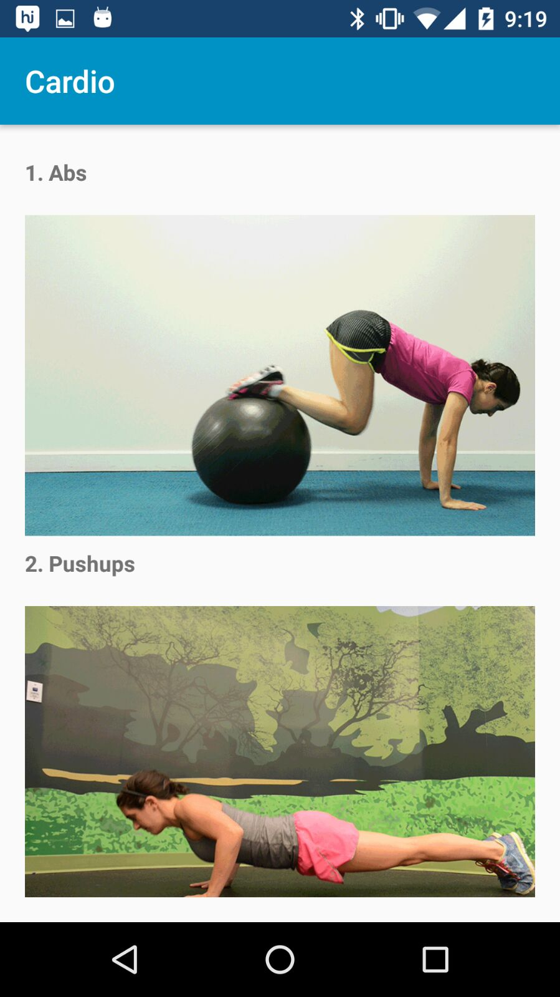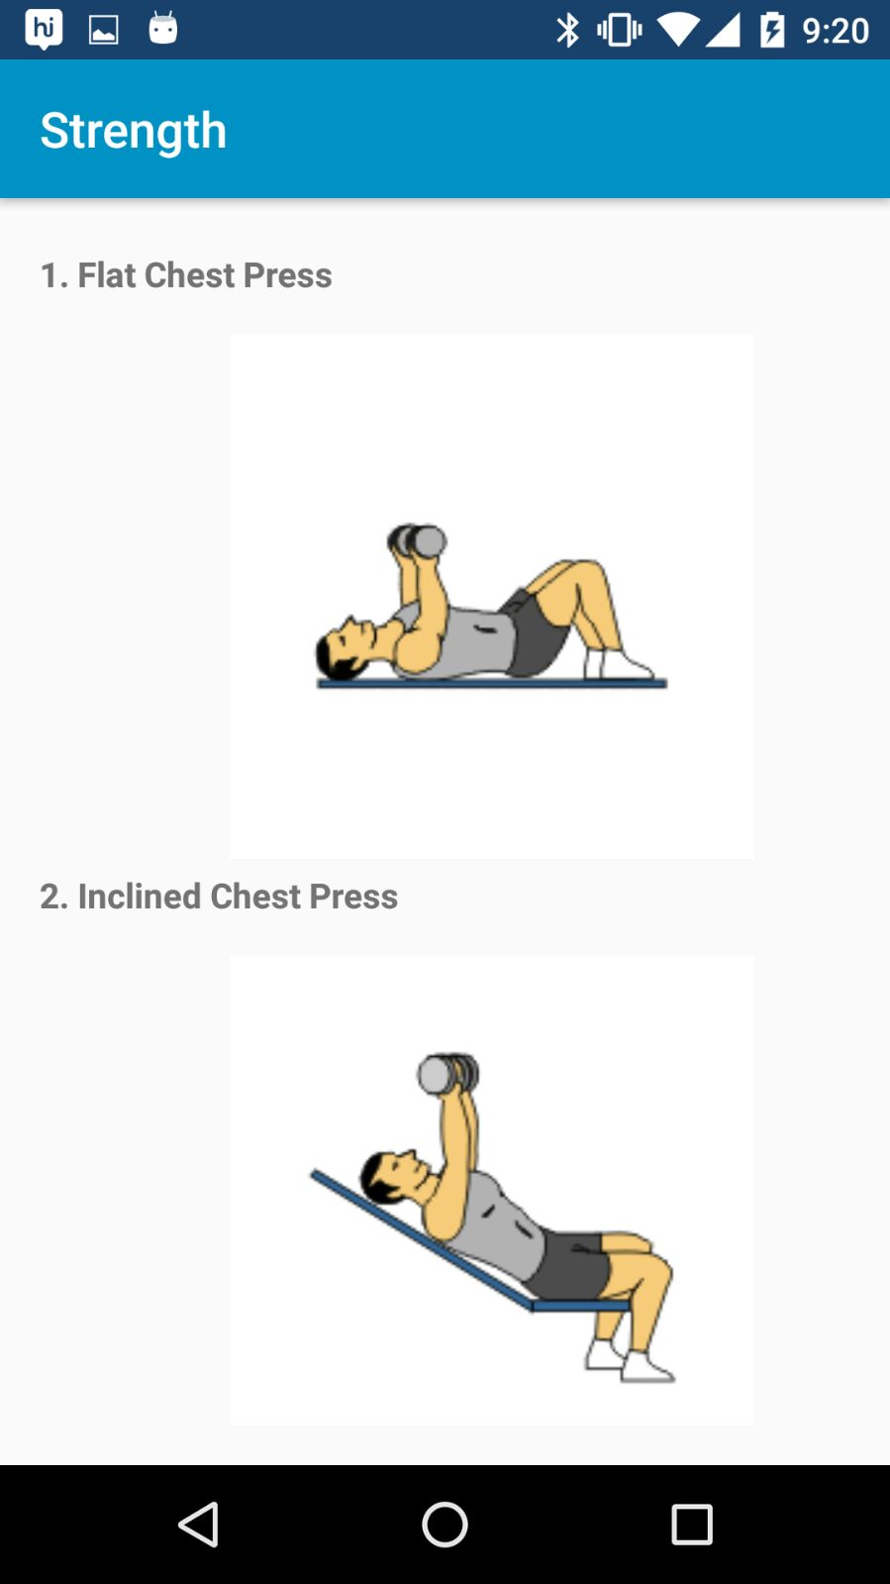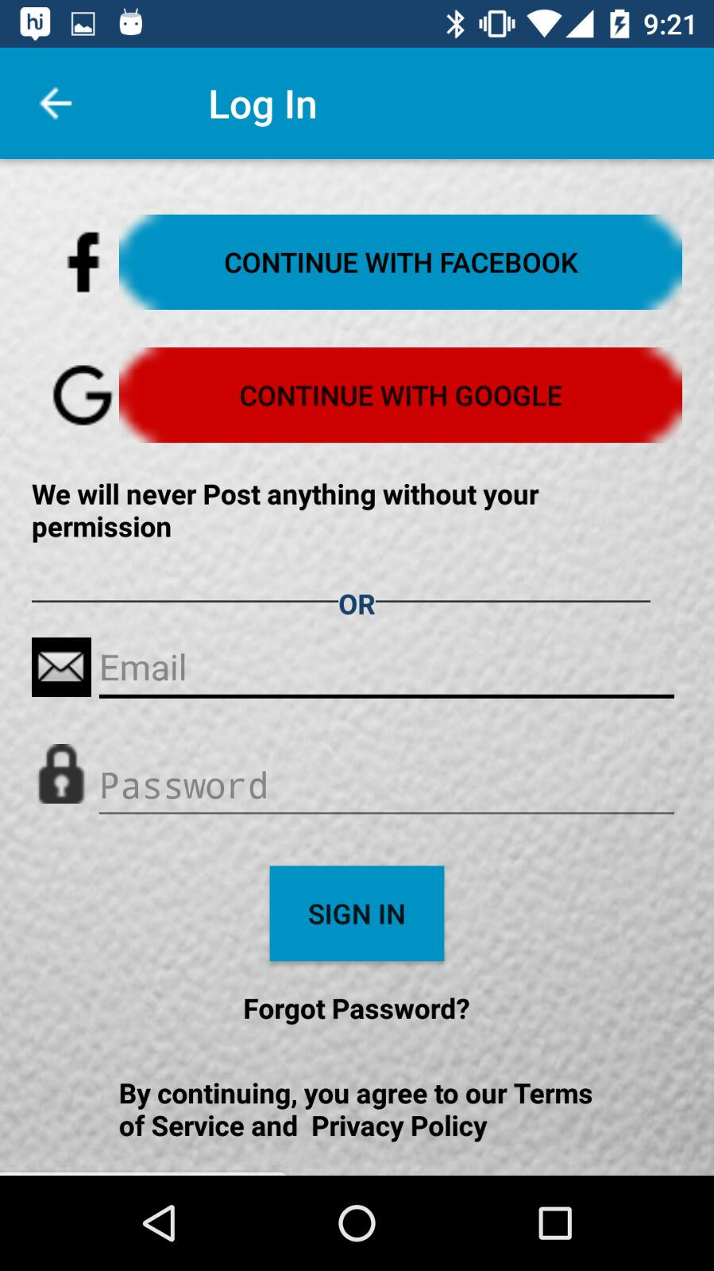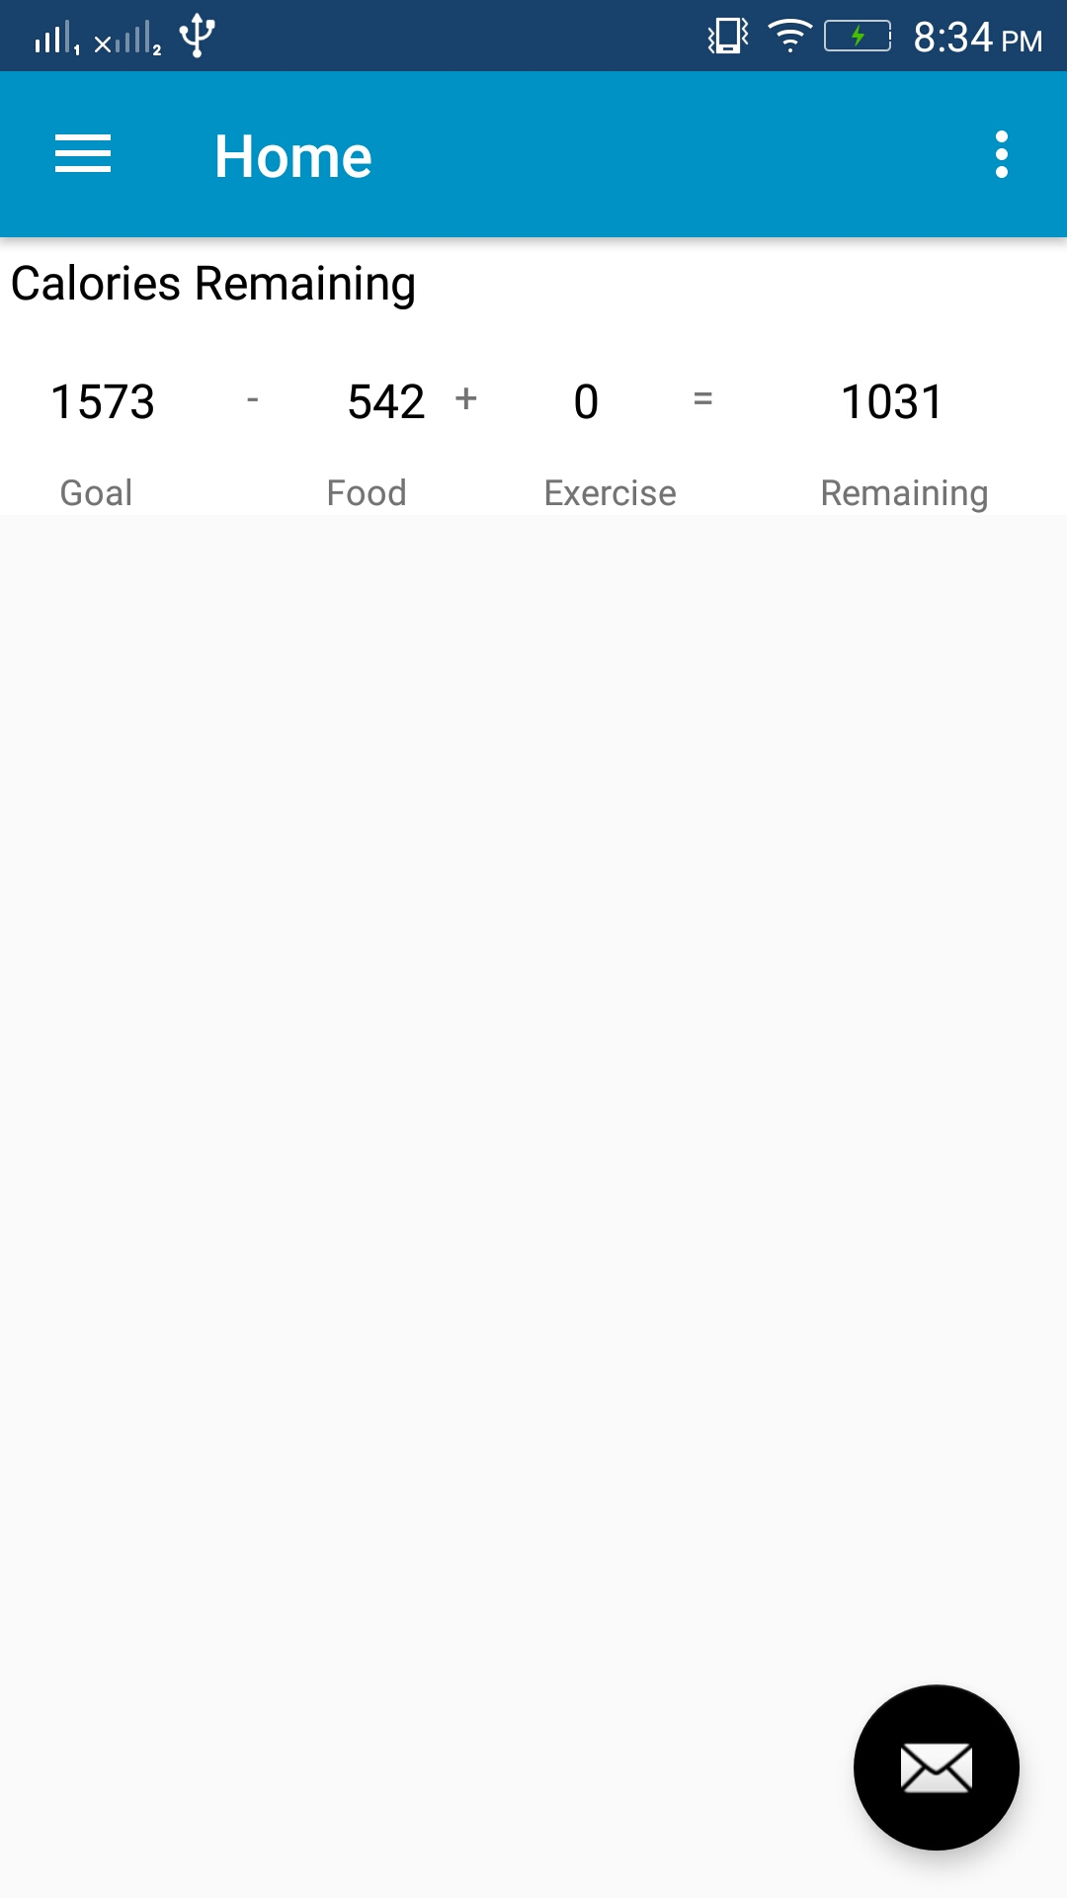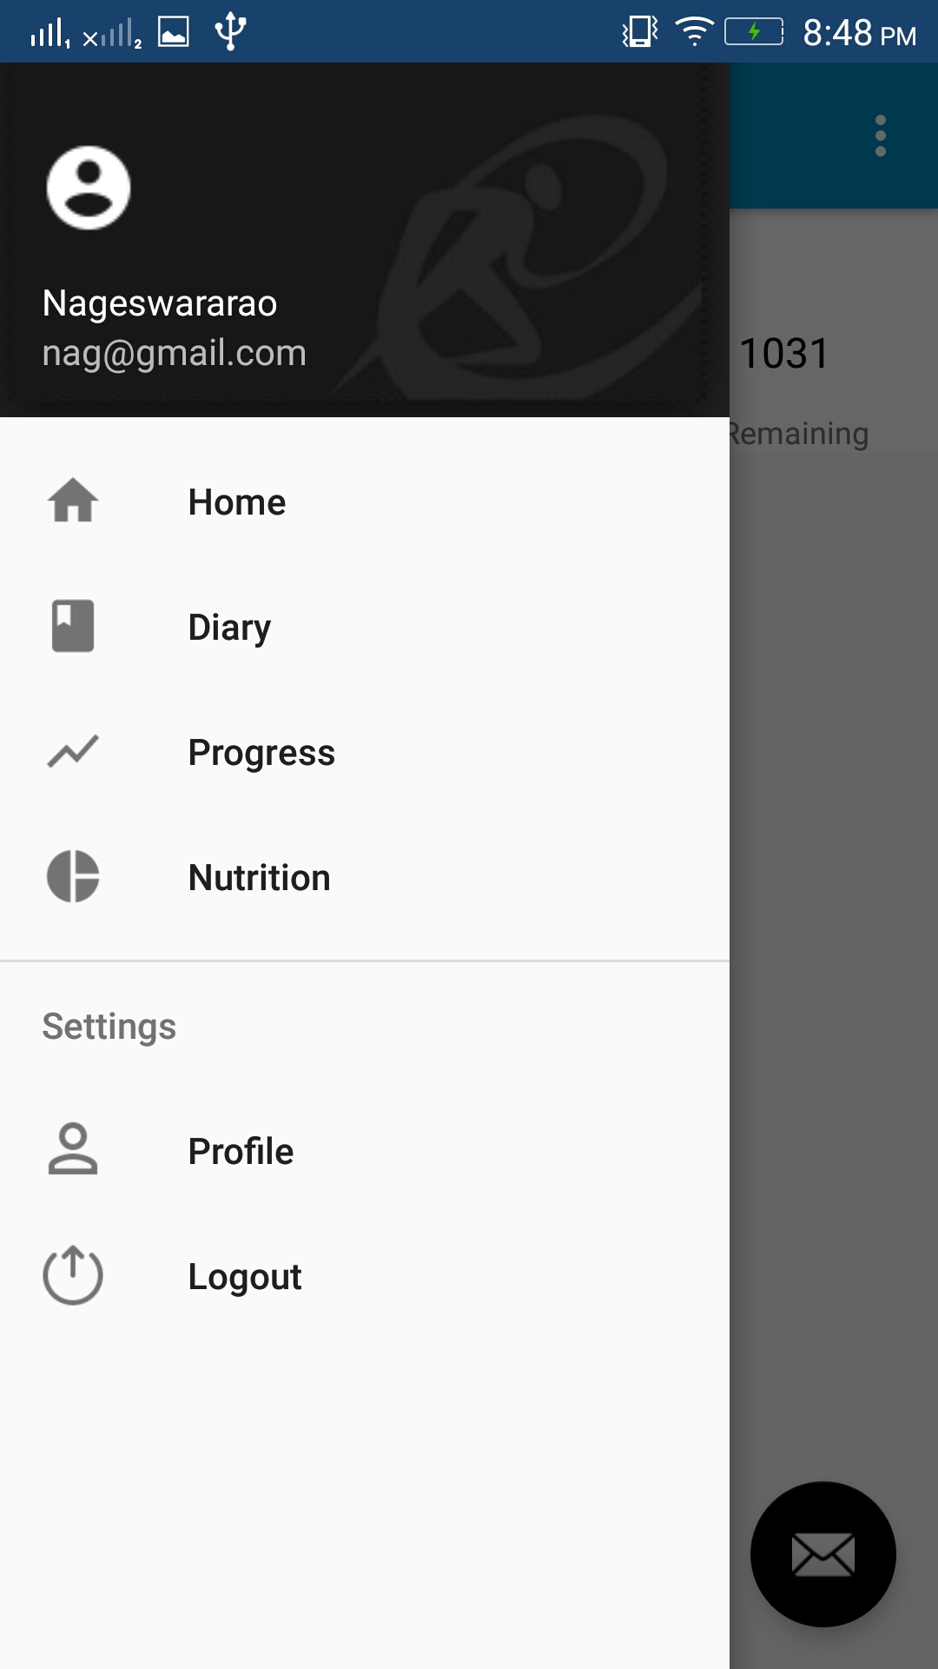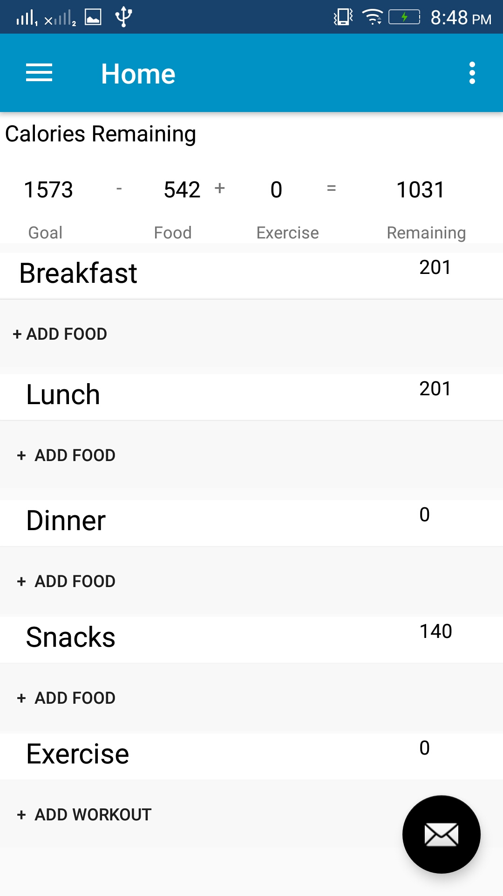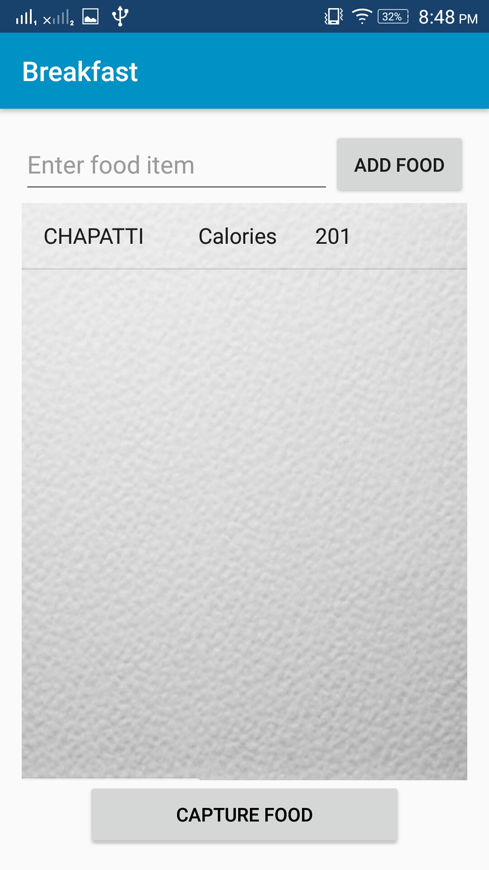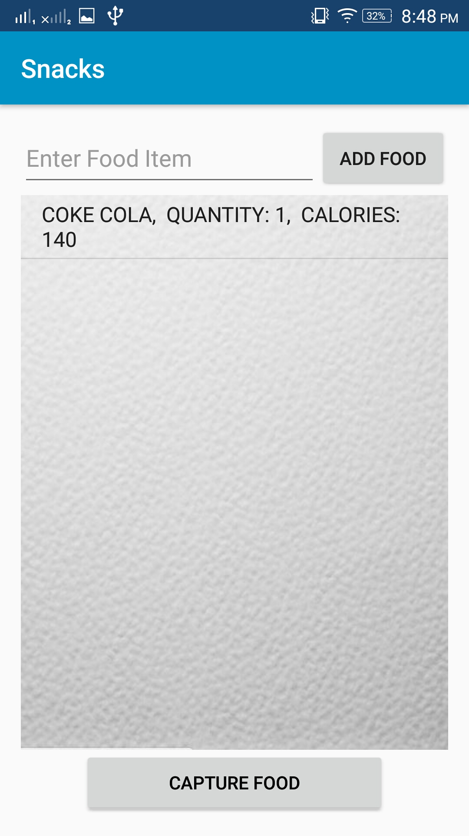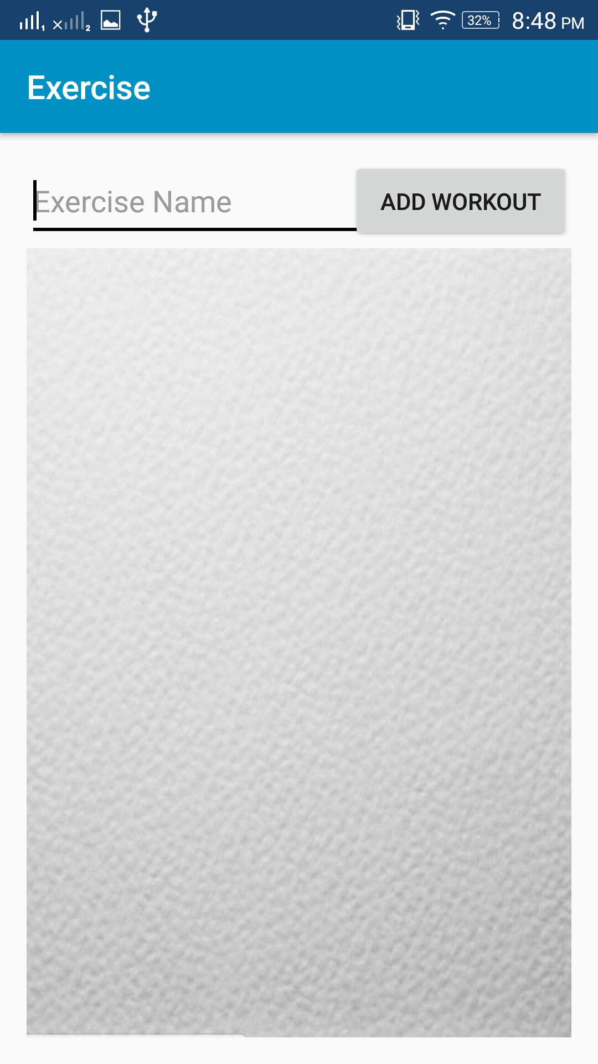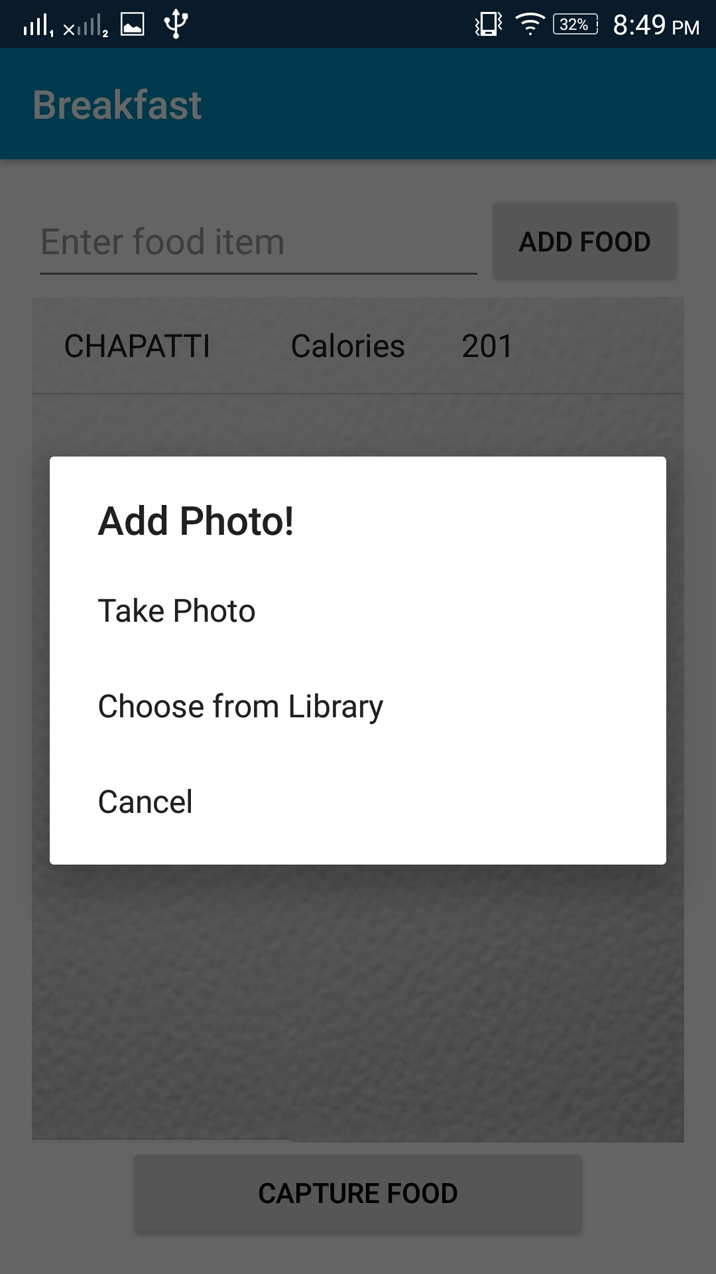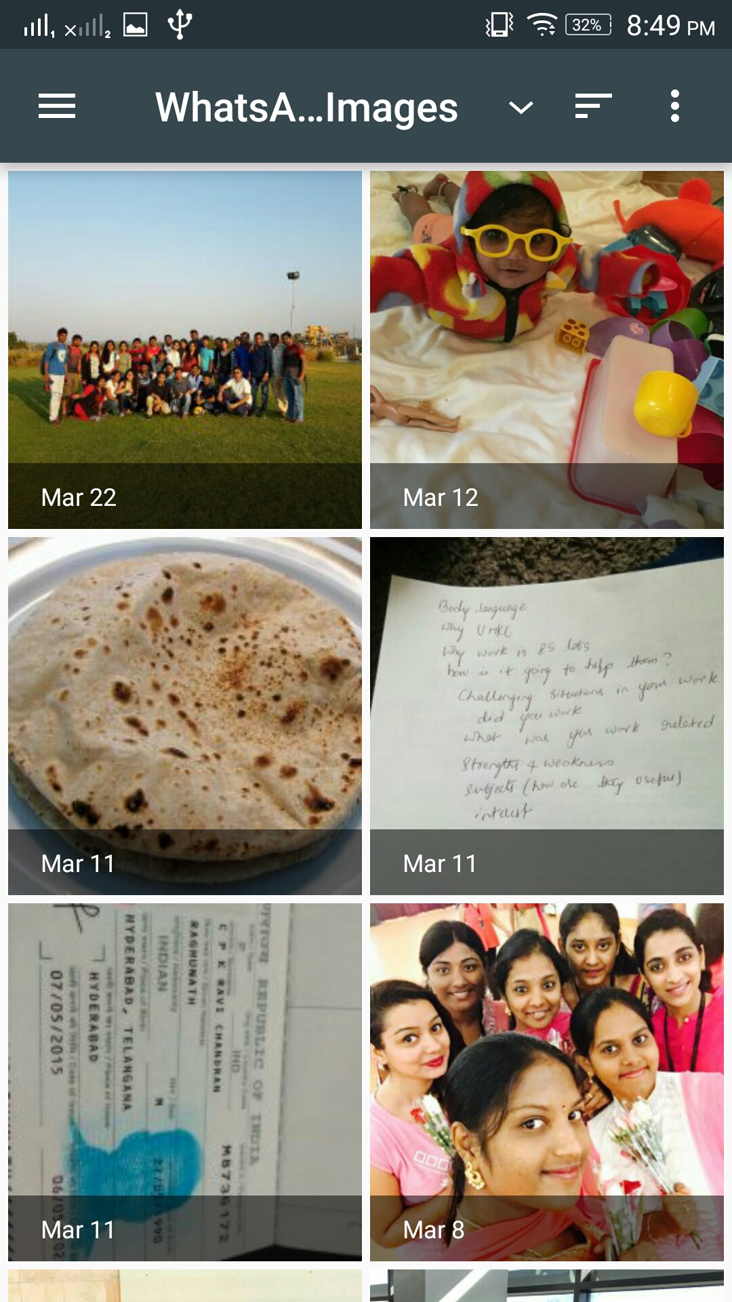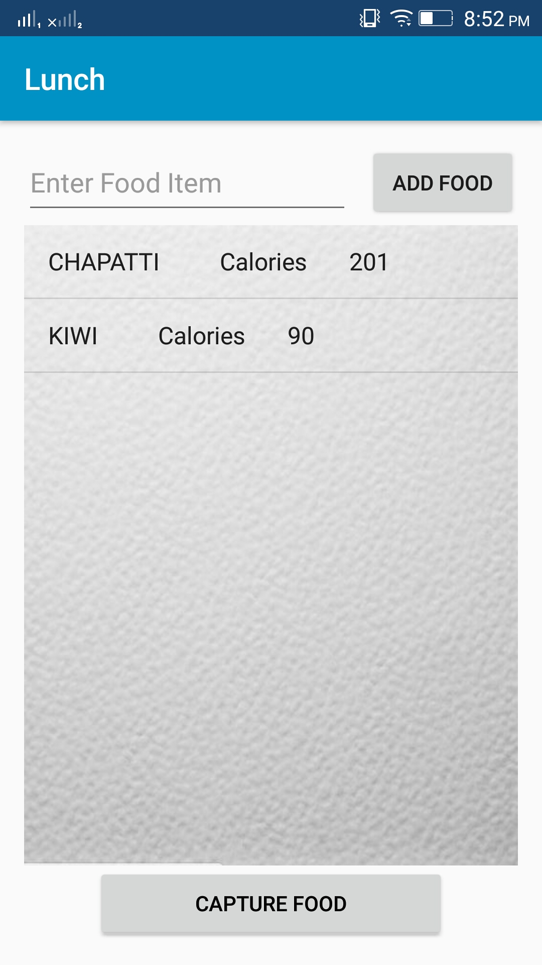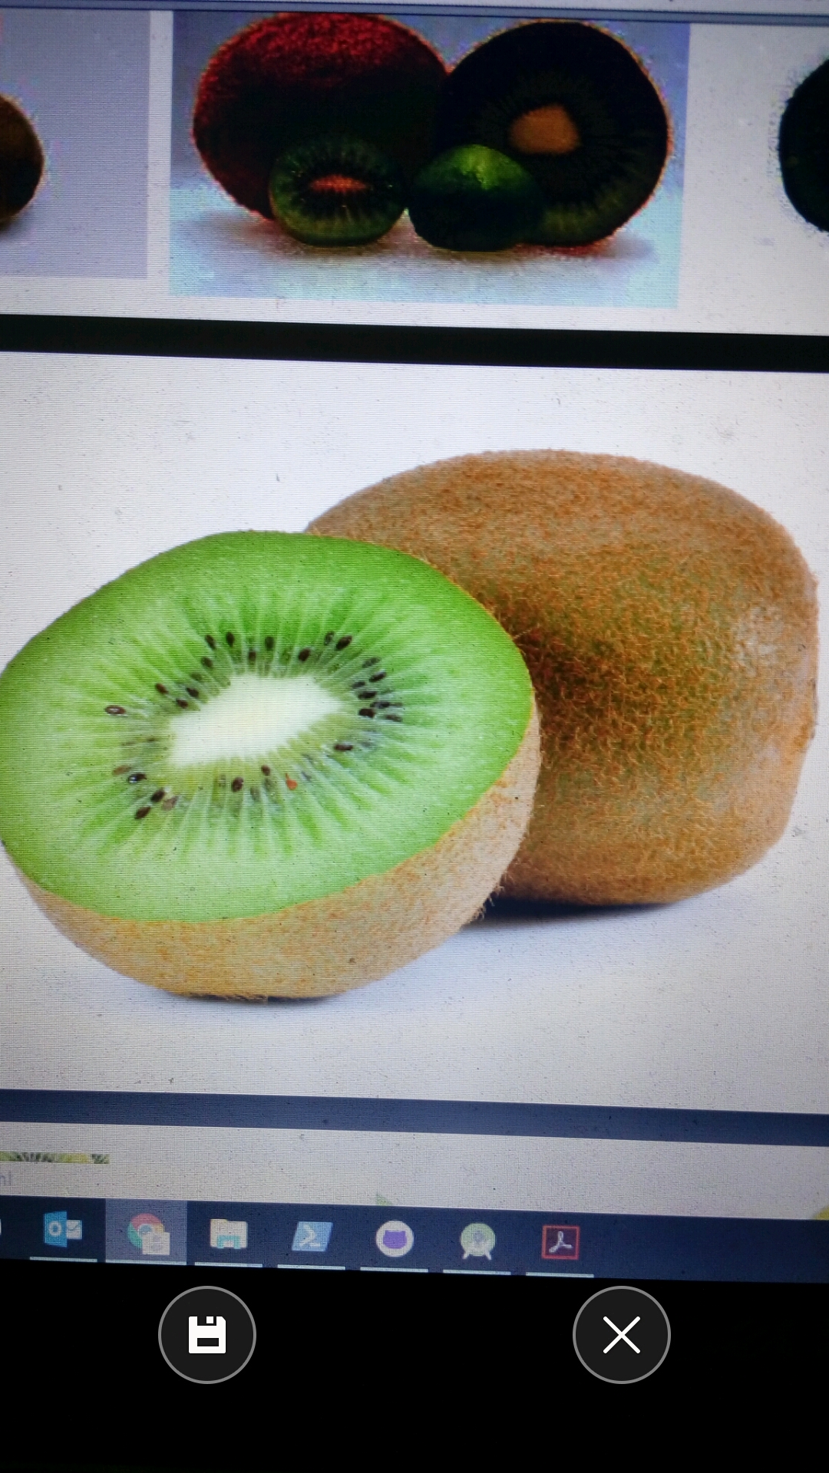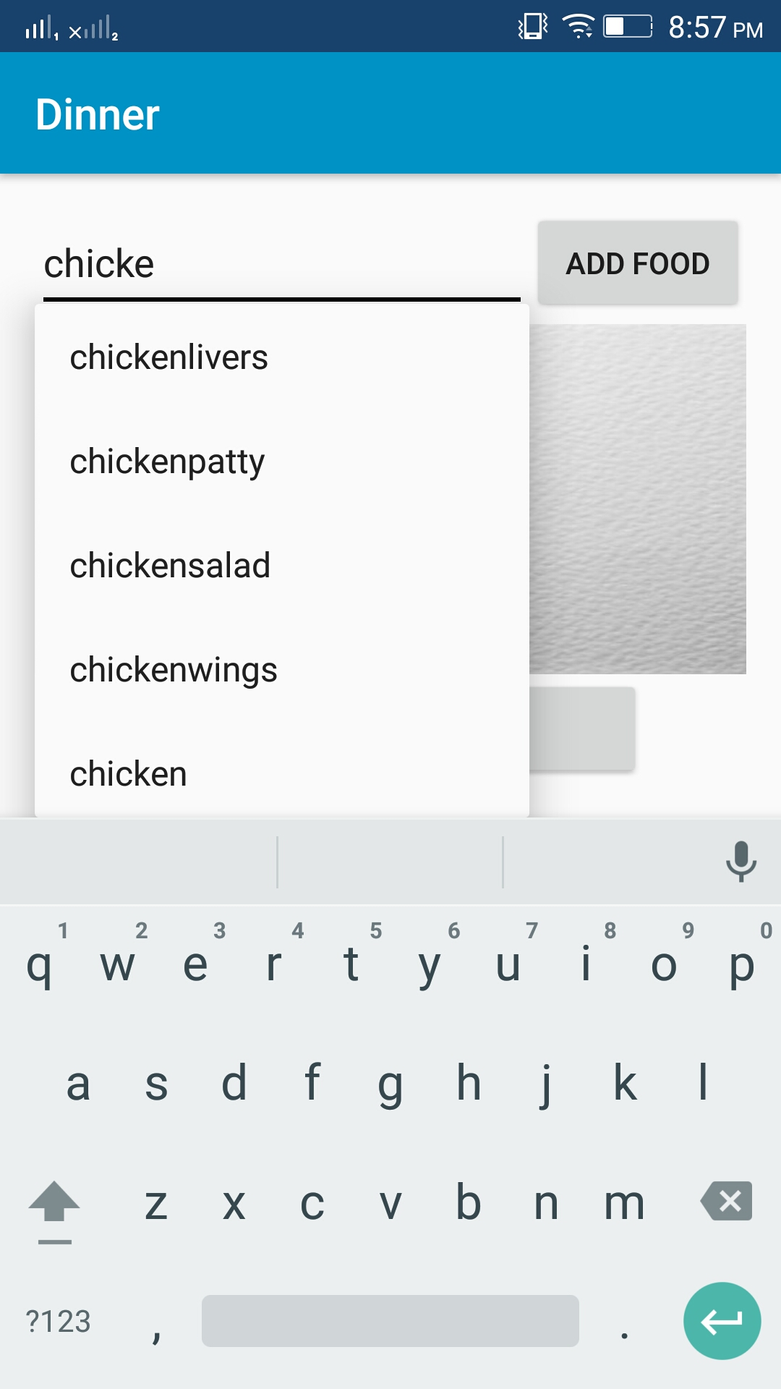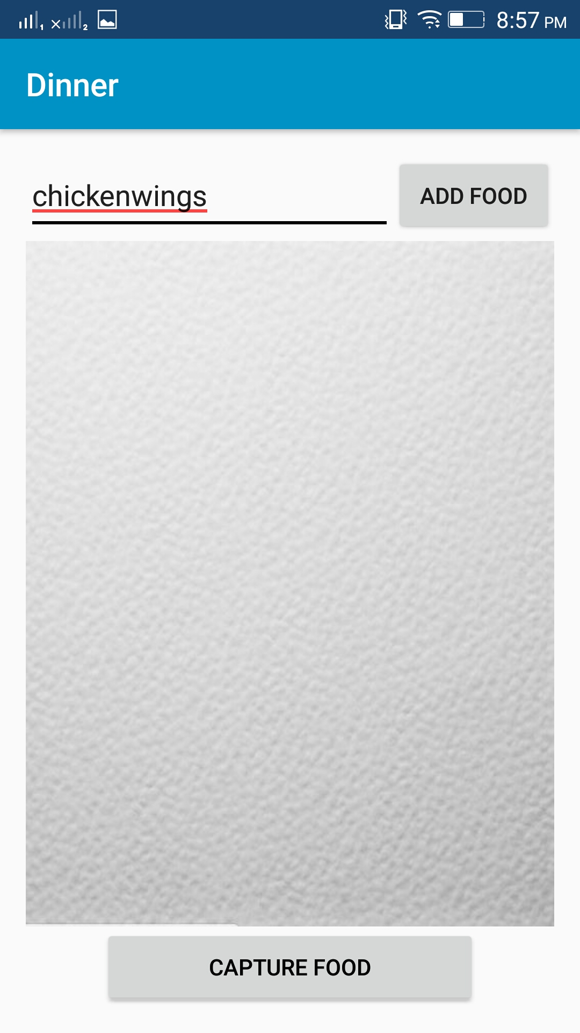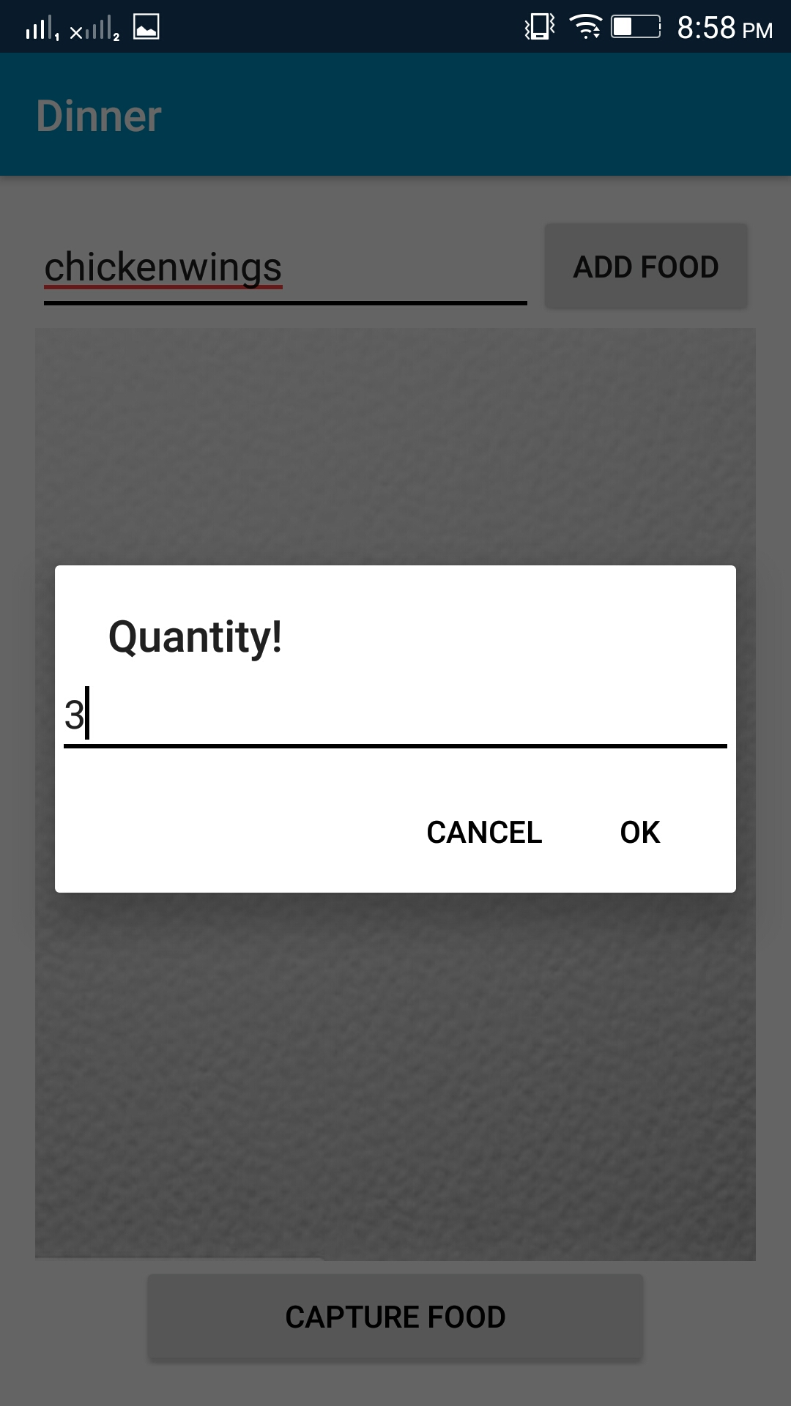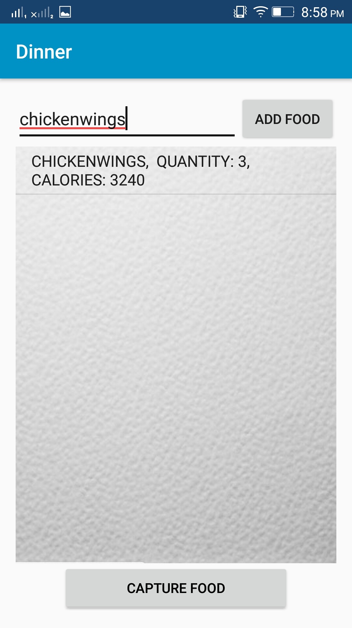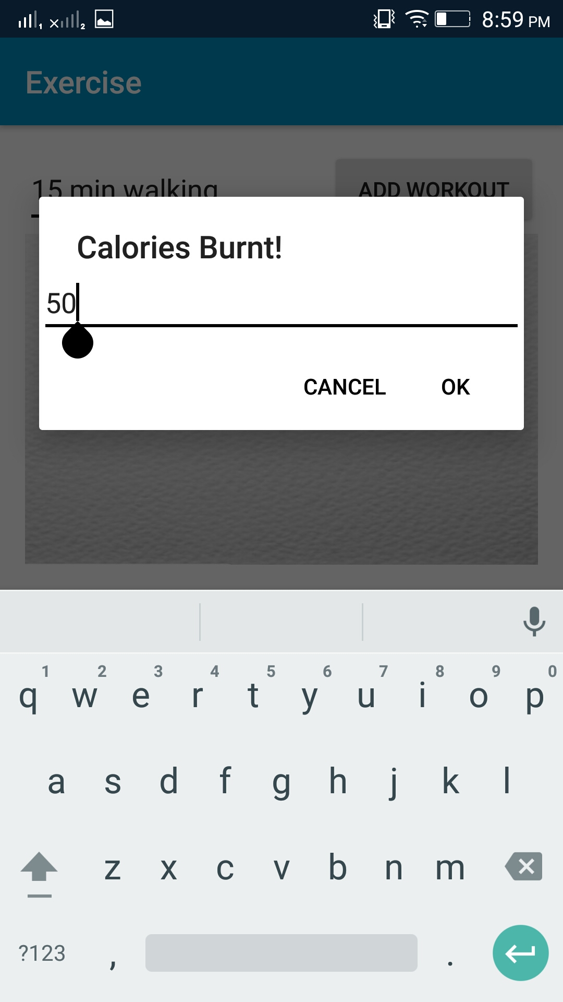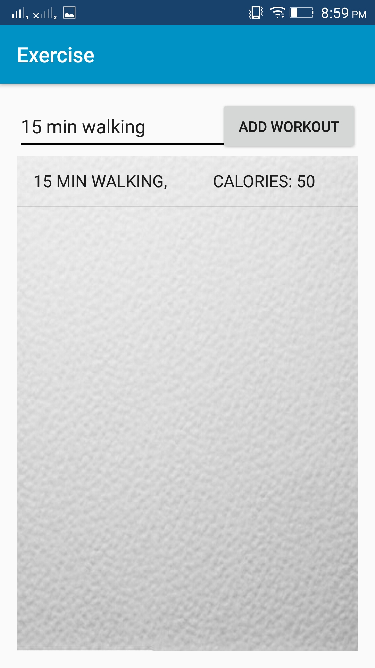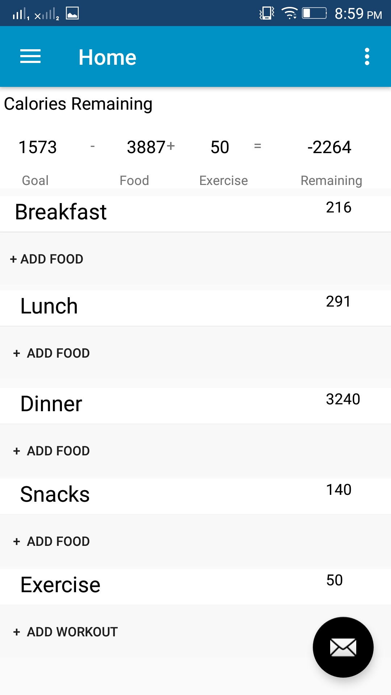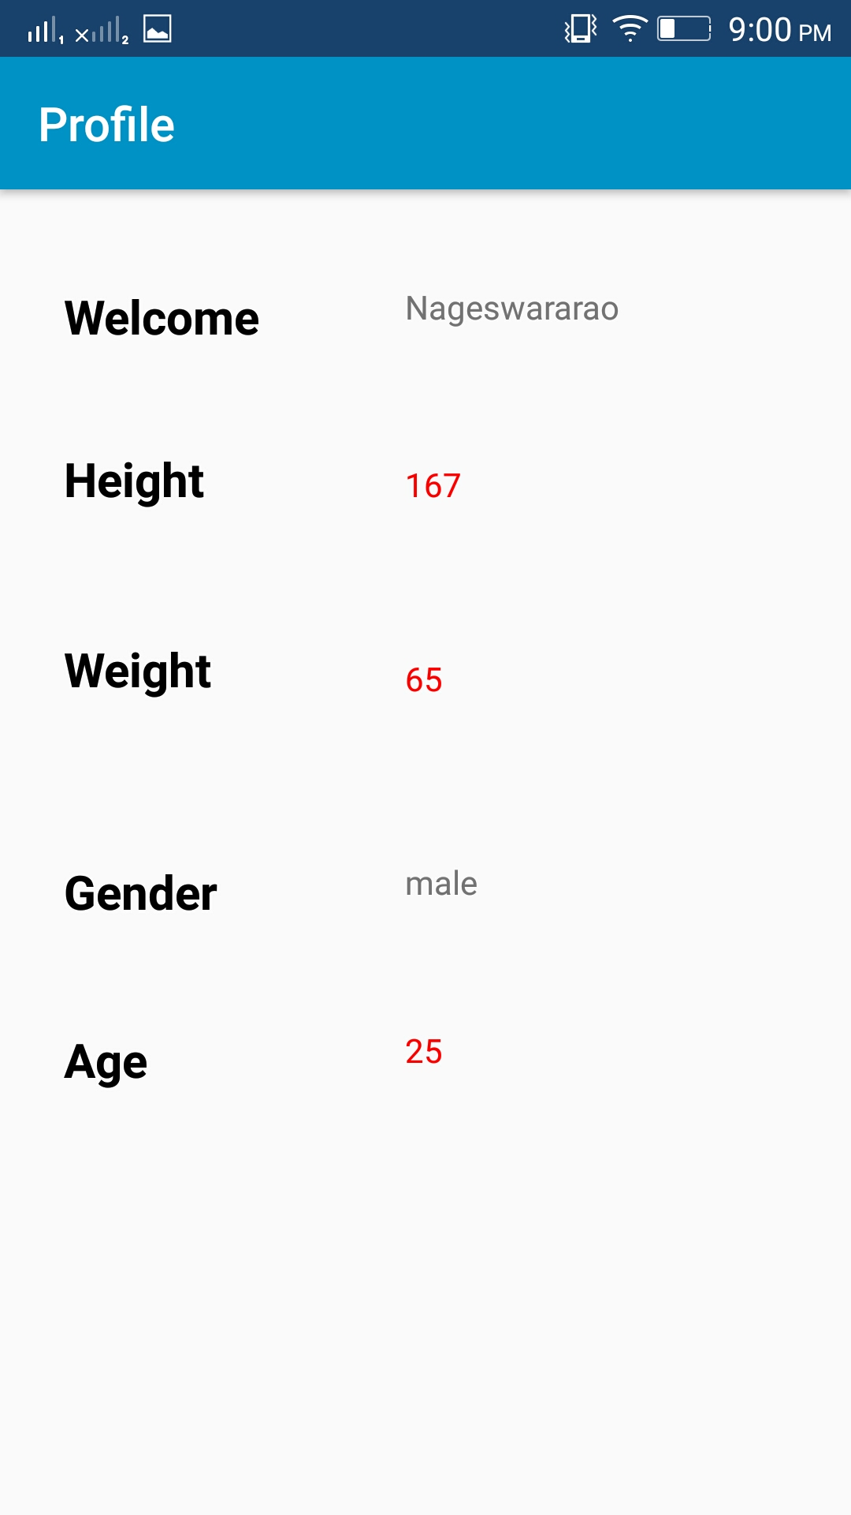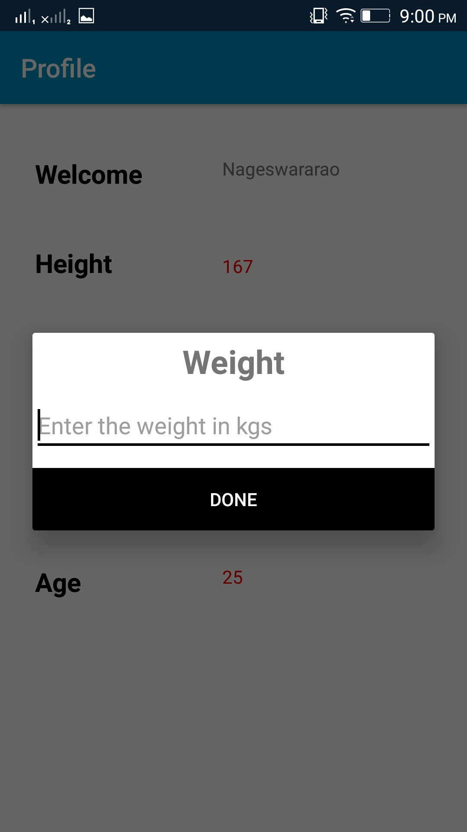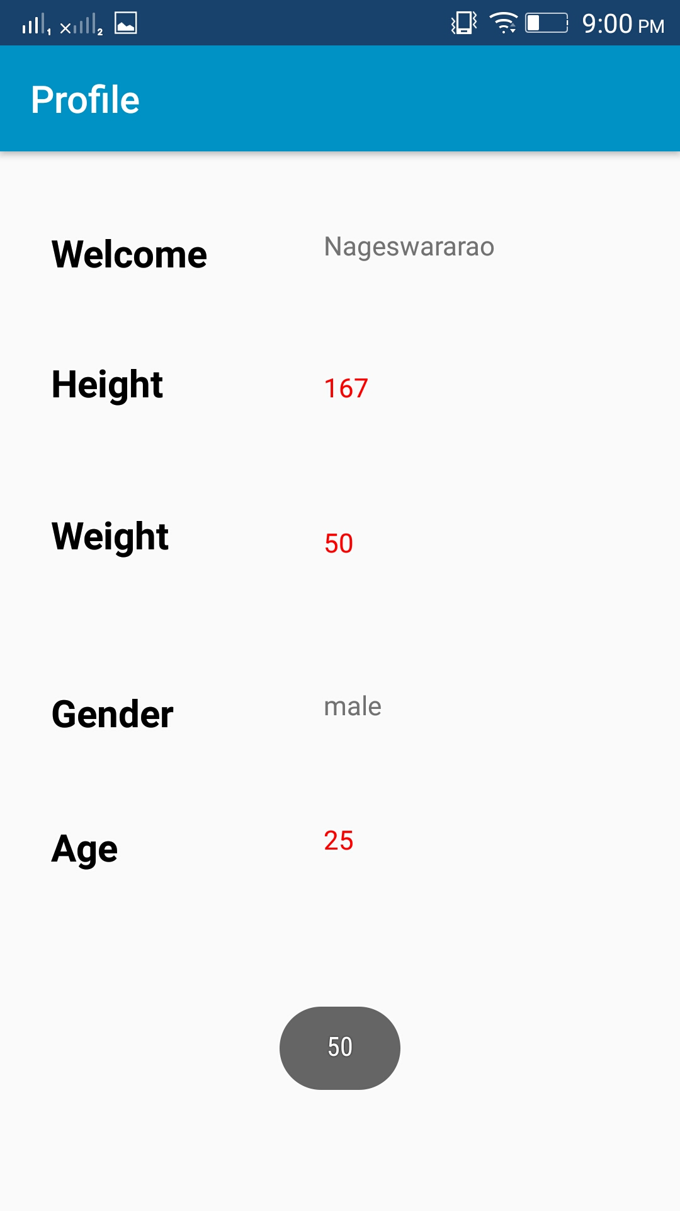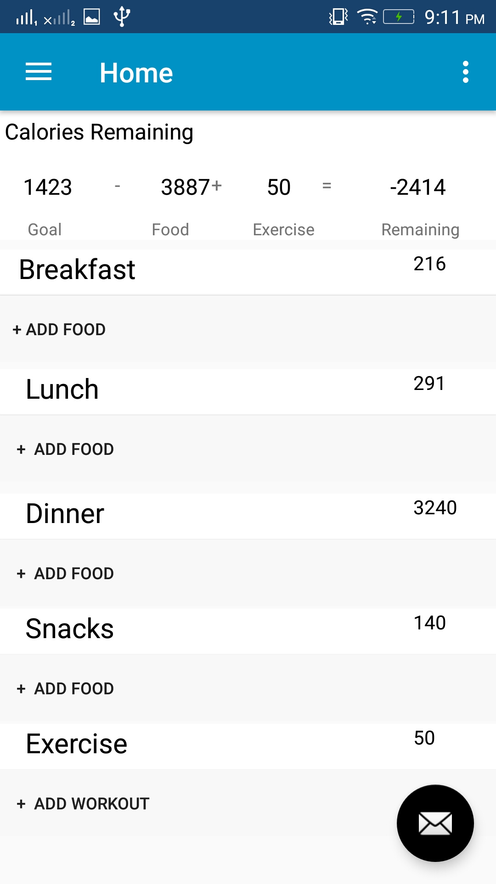

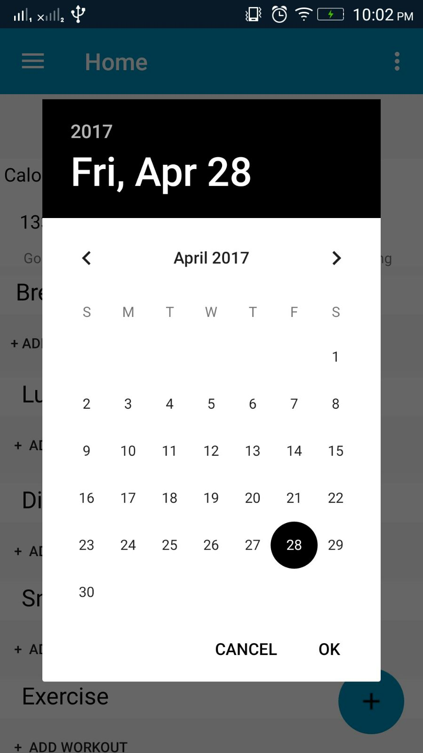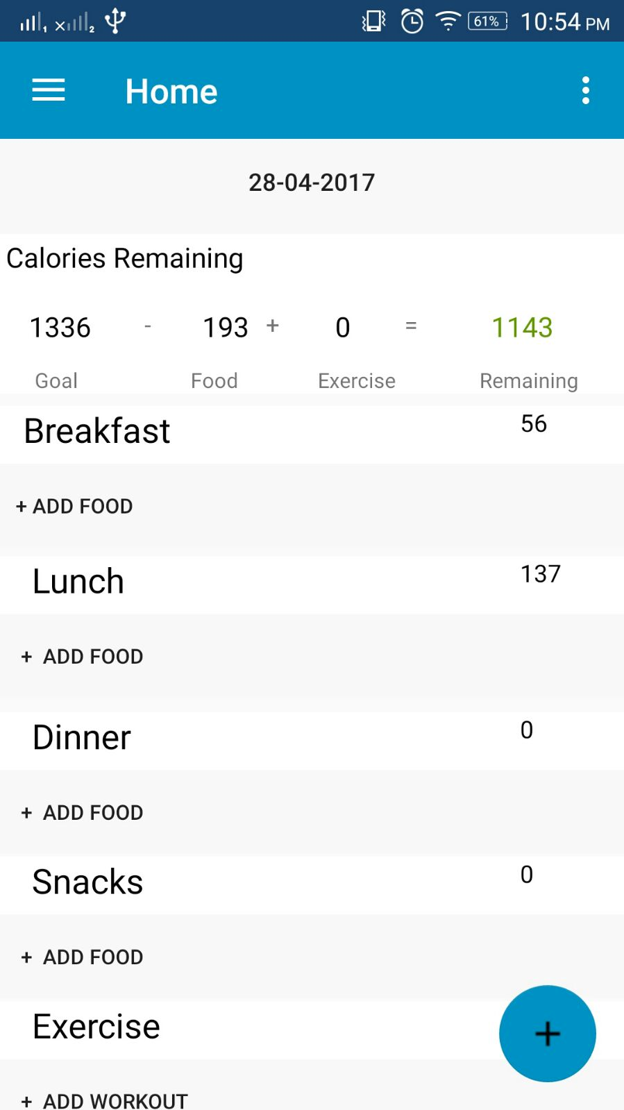

**4.4.4 Github Link**:

The below is the Link for the GitHub Repository in which the project documentation and source code and the project, its analysis in burndowns and Zen hub tools are also present

<https://github.com/DevenderSarda/Project-Fitness-Chef>

* 1. **Project Management**

**4.5.1 Implementation status report**

**4.5.1.1 Work completed**

**• Description**

* + - Fitness chef android application
    - Login and Registration Page
    - Design and working of tracking calories page

**4.5.2.2 Contribution**

**4.5.1.2 Responsibility**

* + Integration of APIs with Master code – Syed Moin & Nageswara Rao
  + Implementation of Exercise and Newsfeed/Tips APIs - Devender & Revanth
  + Implement Home page – Team Task

1. **Bibliography**

<https://www.nutritionix.com/>

<https://developer.android.com/about/versions/nougat/index.html>

<https://material.io/icons/>

<https://developers.facebook.com/>

<https://developer.nutritionix.com/admin/>

<https://visual-recognition-demo.mybluemix.net/>

<https://cloud.google.com/vision/>

<https://ionicframework.com/docs/>